Chapter one
Data Collection
The quality of information depends upon:
1- Source of data.
2- method of collection of data.
3- Recording system.
1- Statistics. Numerical data enable us to propose certain laws which expresses causes Sand effect in day-to-day practice. Thus quantitative data affected by multiple causes are called statistics.
2- Chance: Occurrence of events (in nature) which are occurring as though they are occurring in nature.
3- Null hypothesis: We assume that the difference is zero, i.e. no true difference exists.
4- Quantitative data: They are measurable values like weight, height etc., typically they are continuous data.
5- (Qualitative data): They are characteristic enumeration of subjects, which either are possessed or not possessed; e,g. have: do not have, pass:fail, etc. typically they are discrete data.
6- Bias: A systemic difference between universe and sample.
7- Continuous data: Infinite number of possible points along a continuum.
8- Control group: For evaluating the effect of an experimental procedure, group used as a comparison group.
9- Discrete data: (Infinite) number of possible points along a discontinuum.
10- Data: Attributes or variables without any (meaning).
11- Significant test: It is a test of null hypothesis. If NH is rejected, it is significant and the specified alternative hypothesis is accepted.
12- Sample: It is a portion of an universe or population about which information is actually collected.
13- Sampling error: Occurrence of error by chance in the sampling process. This is the actual difference between sample outcome and universeoutcome, provided both are carred out in the same manner.
14- Accuracy: The (closeness) with which a measured value agrees with the true value.
15- Random sampling: Every element in the population have the opportunity or probability of being selected for the sample. It denotes a method of selecting a sample.
16- (Random sampling ) : is a procedure for selecting a sample which gives every item in the population a known opportunity of being selected, say probability.
17- Continuous variable. It is a potential data which occur in an infinite number of possible values in any interval.
Q1/ Mention the two major types of data?.
First type: quantitative data which result from measurement. Here we are encountered with continuous variable such as weight, height, etc.
Second type: qualitative data which relate to attributes or categories into which people, animals, things are classified such as race, sex, immune status of the body, etc., where we can record yes or no.
Q2. How can you expect a better estimate?
1- Because of chance variation or sampling error.
2- By selecting large sample size.

Chapter two
Q1/ Numerate the types of measurement’s scales of data? And give an example.
- Nominal scale (by name, label, tag).
Example: out come of ND – infected, not infect
- Ordinal \scale: (with implicit order of interrelationship)
Example: Degree of malnutrition – sever, mild, critical.
- Interval Scale: (number between characters)
Example: Body temperature – Degree Fahrenheit.
Heart Rate – Per second
- Ratio Scale: (Relative magnitude)
Example: infection per 1000
Height by weight.
Q/2Numerate the sources of Routine or regular data and explain one of them.
1- Census. 2- Vital registration 3- Diseases notification 4- Diseases registry 5- Medical records 6- Hospital records 7- Environmental health data.
Q3/ Numerate the sources of Non-Routine or adhoc data and explain one of them.
1- Sample registration system. 2- Disease surveillance. 3- Manpower statistics. 4- Surveys. 5- Additional adhoc demographic data. 6- Economic and fiscal data. 7- Security schemes and social schemes
Q4/ What is a survey? And what components are included in general health survey?

Ans.
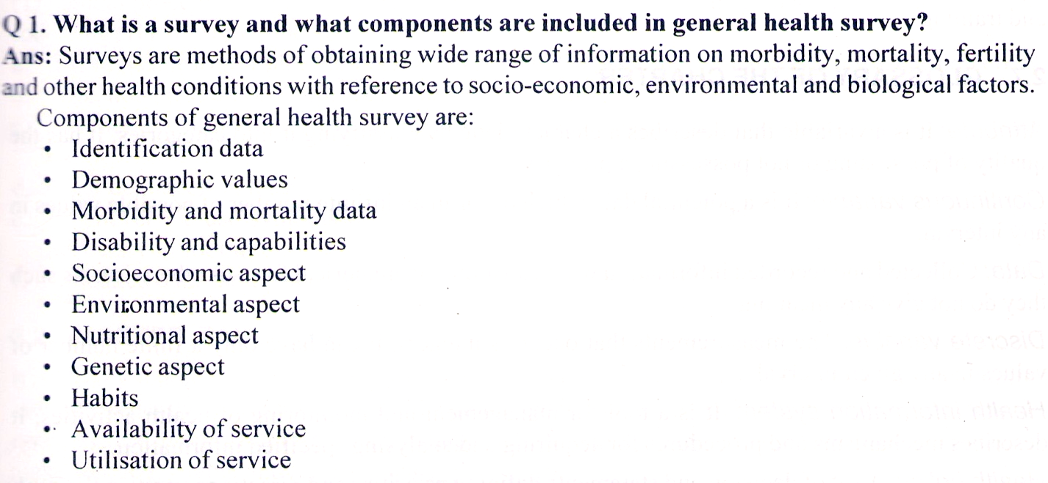

Q5/ Mention simplest nutritional survey and its components.
Ans.
Diet survey is simple and common method of nutritional assessment.
The components are:
1- Weighment of raw foods
2- Weighment of cooked foods
3- Stock inventory
4-Postal questionnaire

Chapter three
1-Data are tabulated by:
1- manual procedure 2- mechanical procedure 3- computer feeding.
2- (Cross table): Two dimensional table in which two variables are cross classified.
3- Frequency table: it is also called (frequency) distribution, which is a tabular arrangement showing the number of times a data with a particular characteristics occur within a set data.
4- Cross table. Two dimensional table in which two variables are cross classified.
5- Master table. Initial recording is transformed to a big master table which contains every detail observation designed in the study. All units and all characteristics are taken into account in master table.
Q1/ Numerate the types of table and give an example to one type?
Types of table:
- Simple table
- Cross table
- Table with multi variable
- Tables prepared only for statistical analysis.
Q2/ Mention the most common mistakes in tabulation, and explain one?
1- omission of major factor. 2- Bias. 3- Tabulation or noncomparable data. 4- Carelessness. 5- Confusion of association and causation. 6- Insufficient data. 7- Unrepresentative data. 8- Misleading totals.

Q3. Prepare a frequency distribution table (showing relative frequency also) for the following data.(Intraocular pressure of right eye).
Sl No. I.O.P.
1 20
2 16
3 12
4 13
5 23
6 9
7 9
8 13
9 19
10 17
11 19
12 14
Q4/ Prepare a frequency distribution table for the following data. (weight in Kgm). And count the relative frequency of each weight group)?
65, 68, 70, 69, 60, 65.5, 75, 63, 66.5, 69, 61, 71, 79, 84, 73, 75, 56, 64.5, 77, 71.
Q5/ Prepare a frequency distribution table for the following data. (Length in cm). And count the relative frequency of each weight group)?
185, 170, 165, 166, 161, 164, 167, 165, 167, 174, 171, 169, 173, 176, 180, 173, 179, 174, 177, 181.

Chapter four
1- Bar diagram: Diagrammatic presentation of frequency data for normal classes by bars. Length of bars is proportional to the class frequencies.
2- Cumulative frequency. The frequency obtained by cumulating the frequencies of previous classes including the class in question. It shows the total observations upto the end of a particular class in the curve.
3- Frequency table. It is a distribution table, where the data shows the number of times it occurs within a data set.
4-Ogive. It is the graph obtained by the cumulative relative frequency distribution, which may be more than or less than ogive.
5- Pie chart. A circle is used where sectors of the circle are shown proportional to class frequencies. Very commonly used in data presentation of normal classes.
6- From frequency table, data on variable is represented on X axis and the frequency on Y axis.
7-The rectangles drawn are called bars. In case of qualitative data bar represents the frequency of a group. In case of quantitative data bar represents frequencies of a class interval. Breadth of bar represents characteristic group in case of qualitative data and represents length of class interval in case of quantitative data. The base will have equal width. Height of bar it self will tell us the comparison.
Q1/Why we uses the graphical representation?
1- Easy for comparison
2- Trend in the observation can be noticed with respect of time.
3- Lay people can understand it.
4- Median, percentile, quartile, etc. can be calculated.
5- When lot of fluctuation are seen, then semilog or double log graphs can be good representations.

Q/2 What are the types of condensing data to graphic form?
i. Bar chart (vertical and horizontal)
- Simple
- Multiple
- Component
ii. Histogram
iii. Frequency polygon
iv. Cumulative frequency curve
v. Line diagram
vi. Pie diagram
vii. Pictogram
viii. Scatter diagram
ix. Map diagram.

Q/3 Construct a cumulative frequency curve ( both more and less than ogive) from the following data:

X freq.
1- 0-10 2
2- 10-20 7
3- 20-30 13
5- 30-40 28
6- 40-50 12
7- 50-60 6
8- 60-70 2
Ans.
X freq. cf (cumulative frequency)

1- 0-10 2 2 70
2- 10-20 7 9 68
3- 20-30 13 22 61
5- 30-40 28 50 48
6- 40-50 12 62 20
7- 50-60 6 68 8
8- 60-70 2 70 2
70 more than ogive less than ogive
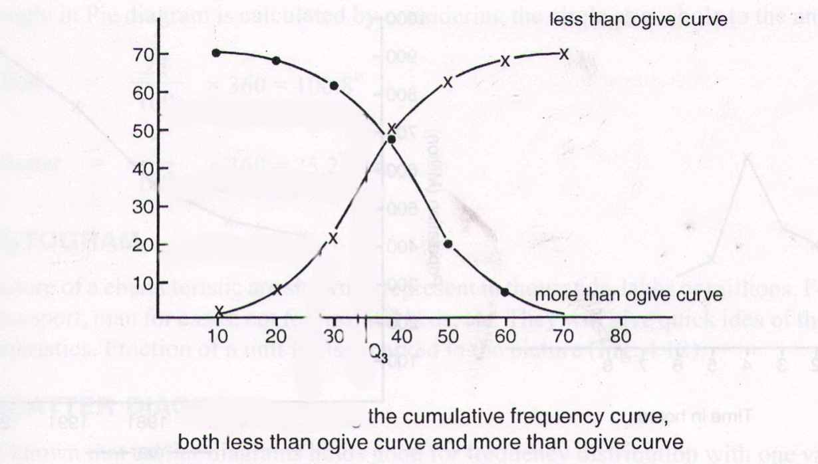

Q4/ Construct a pie chart for the following data;
Knowledge about exclusive breast-feeding (mothers) Number
Yes 112
No 14
Do not know 39
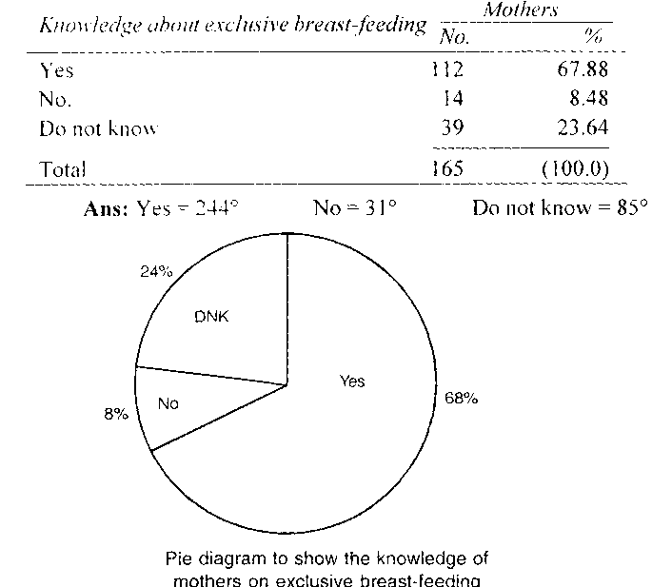
Total 165

Q5/ Construct a multiple bar diagram for the following data:
Age Male No. Female No. Total
0-20 83 56 139
20-30 244 65 309
30-40 140 4 144
40-50 25 2 27
50-60 12 1 13
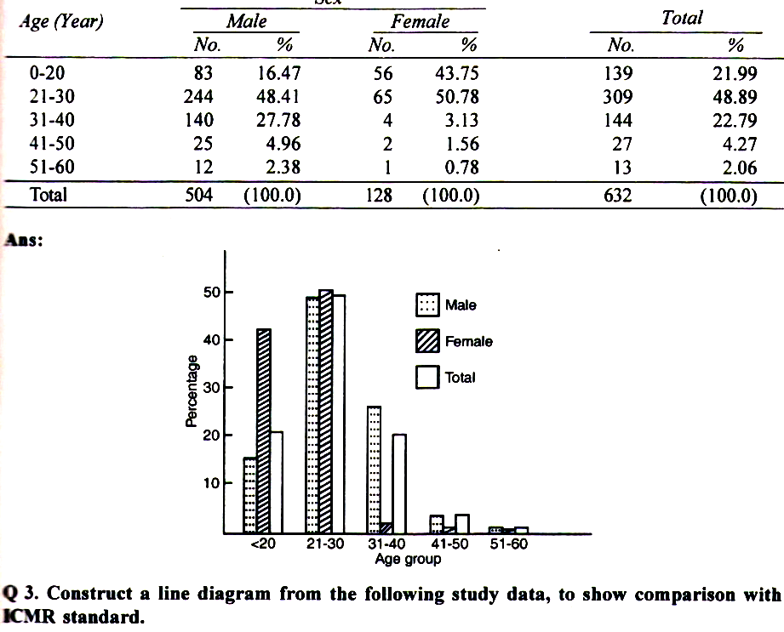

Q6/ Construct a line diagram from the following study data, to show comparison
with ICMR standard:
Age in years Mean value ICMR value
5 16.8 14.1
6 17.8 15.2
7 19.3 17.9
8 20.9 19.1
9 23.3 20.3
10 25.9 23
11 26.1 25.1
12 29.2 28.6
13 29.2 28.6
14 31,4 34.5
15 38.1 38.3
16 39.9 40.2
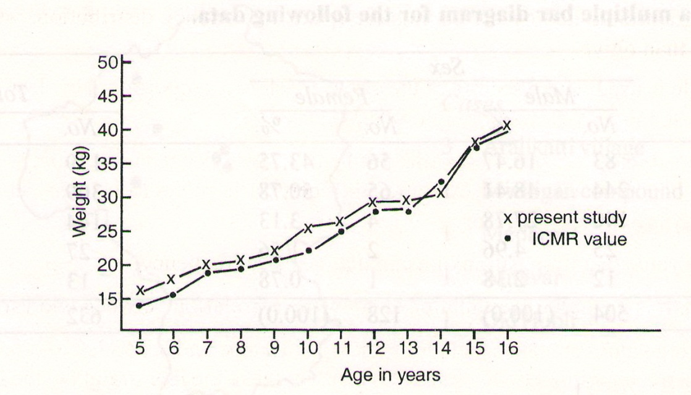

Chapters five and sex
Measures of central tendency and variability
1- Arithmetic mean. The sum of all values of observations divided by number of observations. This is a commonly used average.
2- Measured of central tendency. Mean, median, and mode are the three summary indices which describe the central point. The central tendency indicate most characteristics value of a set of measurements in quantitative data.
3- Median. When the values are arranged in an order of magnitude, the central value which divides the distribution into two equal parts is mean.
4- Mode. The most fashionable or the most frequently occurring value in a series of observation.
5- Coefficient of variation. Independent of scale of measurement, SD is expressed as percentage of the mean.
6- Mean deviation. The average of the differences between the mean and each of the values of the observation in an observation.
7- Range. It is the difference between largest value and smallest value in a series of observations.
8- Class interval. It is an interval to which a range of variable has been divided.
9- Variance. It is sum of squared deviations taken from the mean, divided by number of observations. Values are in scales similar to observational values.
10- SD. It is root-mean-square deviations have been taken from the mean, which is equal to the square root of the variance and values are expressed in same scale of observational values.
Q1/ Following are I.Q. of 10 individuals recorded at psychiatry OPD.
158, 139, 120, 146, 111, 99, 114, 156, 111, 94.
Compute mean, median and mode.

Ans.
a. AM = 124.8
b. They are arranged in an ascending order
94, 99, 111, 111, 114, 120, 139, 146, 156, 158.
Central values are 114 and 120
Median = Average of central values = = 117
c. mode = 111
Q2/ The following data indicate potassium concentration in sheep blood: 5.5, 8, 10.5, 11, 12, 14, 15, 16, 16.5, 17, 17, 18.5, 19, 19.5, 20, 20.5, 22, 23, 24, and 28, mmeq/l blood. Compute ungrouped mean an grouped mean (use 5 groups).
Q3/Compute mean, median, mode for the following distribution.
Age group (year) No. of persons
20-30 3
30-40 18
40-50 26
50-60 17
60-70 6
a- Mean computing
Age group (x) Mid point (x) Frequency (f) f X x value(f) (x)
20-30 25 3 75
30-40 35 18 630
40-50 45 26 1170
50-60 55 17 935
60-70 65 6 399
70 3200
AM = = = 45.71
b- Median computing
Median = L + x C
Median = 40 + x 10 = 45.3846
c- Mode computing
Mode = L + { 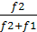 } x C =
Mode = 40 + { } x 10 = 44.7059
Q4/Calculate the median for the following distribution using graphic method.
Age group (year) No. of persons
5-10 3
10-15 18
15-20 26
20-25 17
25-30 6

Ans.
Age group No. of persons Cumulative Frequency
5-10 3 3
10-15 18 21
15-20 26 47
20-25 17 64
25-30 6 70

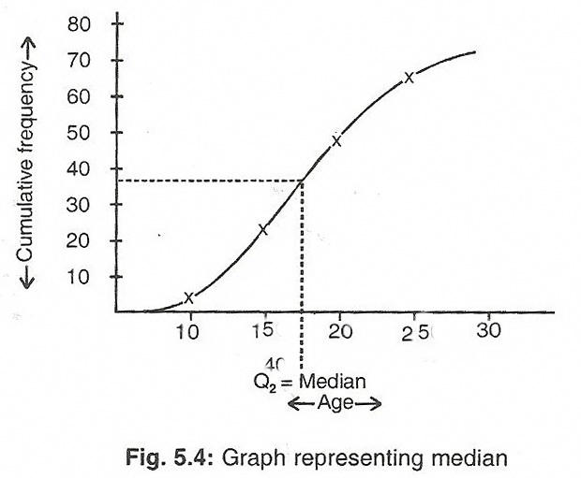

Q5/ Find the Range for the following and comment.
A: 40 , 40, 40, 40, 40, 40, 40, 40, 40.
B: 36, 37, 38, 39, 40, 41, 42, 43, 44.
C: 1, 9, 20, 30, 40, 50, 60, 70, 80.
D: 0, 0, 0, 0, 0, 0, 0, 0, 36.

Q1a/ Compute mean , median and mode of following data which represent the body weight of 20 individuals using ungrouped and grouped data.
64, 68, 67, 56, 70, 74, 77, 60, 72, 68, 61, 71, 68, 75, 69, 80, 74, 65, 67, and 66.
Ans.
1- Mean
a- Ungrouped data:
∑X = 1372
n = 20
x = 1374 ÷ 20 = 68.6
b- Grouped data:
Lower limit = 56, upper limit = 80
80 – 56 = 24, If making 5 group, so the rang =
24 ÷ 5 = 4.8 or 5
55 — 60 60 — 65 65 — 70 70 — 75 75 — 80
II III IIIII IIIII II
III
2 3 8 5 2

So the frequency table :
B.W f mid point fx cumulative f.
55 — 60 2 57 5 115 2
60— 65 3 62.5 187.5 5
65 — 70 8 67.5 540 13
70 — 75 5 72.5 362.5 18
75— 80 2 77.5 155 20
n 20 fx 1360
Grouped mean x = 1360 ÷ 20 = 68

2- Median:
a- Ungrouped
first we arrange the data up words
56, 60, 61, 64, 65, 66, 67, 67, 68, 68, 68, 69, 70, 71, 72, 74, 74, 75, 77, and 80.
The median digit 10 and 11
Me = (68 + 68) ÷ 2 = 68 Kgm
b- Grouped median:
B.W f cumulative f.
55 — 60 2 2
60— 65 3 5
65 — 70 8 13
70 — 75 5 18
75— 80 2 20
Me = L + × C
L- lower limit of median class
n- Number of observation
F- Cumulative frequency preceding median class
f- frequency of median class
C- Class interval.
= 65 + 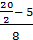 × 5 = 68.125 Kgm
3- Mode:
Ungrouped:
Mo = 74
Grouped:
Mo= L + { } x C
L- Lower limit of median class
f2- Frequency difference to preceding class of median class.
f1- Frequency difference to succeeding class of median class.
C- Class interval.
Mode = 65 + { } x 5 = 68.13
Q1b/ Compute SD of ungrouped and grouped data of the same variables?
a- Ungrouped SD:
∑X = 1372
N = 20
(∑X)² = 1882384
∑X² = 94776
SD = 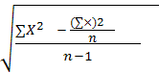
SD = 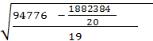 = 5.88
B- Grouped SD:
SD = 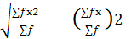
B.W f mid point fx fx²
55 — 60 2 57.5 115 6612.5
60— 65 3 62.5 187.5 11718.75
65 — 70 8 67.5 540 36450
70 — 75 5 72.5 362.5 26281.25
75— 80 2 77.5 155 12012.5
n 20 ∑fx 1360 ∑fx² 93075

SD = 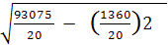 = 5.45

Q2a/ Compute mean , median and mode of following data which represent the body weight of 20 individuals using ungrouped and grouped data.
71, 74, 56, 75.5, 64, 65.5, 60.5, 68, 65, 74, 62, 78, 80, 74, 66, 71.5, 70, 69, 70 and 68.
Ans.
1- Mean
a- Ungrouped data:
∑X = 1382
n = 20
x = 1374 ÷ 20 = 69.1
b- Grouped data:
Lower limit = 56, upper limit = 80
80 – 56 = 24, If making 5 group, so the rang =
24 ÷ 5 = 4.8 or 5
55 — 60 60 — 65 65 — 70 70 — 75 75 — 80
I IIII IIIII IIIII III
II
1 4 7 5 3
So the frequency table :
B.W f mid point fx cumulative f.
55 — 60 1 57 5 57.5 1
60— 65 4 62.5 250 4
65 — 70 7 67.5 472.5 12
70 — 75 5 72.5 362.5 17
75— 80 3 77.5 232.5 20
n 20 fx 1375
Grouped mean x = 1375 ÷ 20 = 68.75
2- Median:
a- Ungrouped
first we arrange the data up words
56, 60.5, 62, 64, 65, 65.5, 66, 68, 68, 69, 70, 70, 71, 71.5, 74, 74,74, 75.5, 78, and 80.
The median digit 10 and 11
Me = (69 + 79) ÷ 2 = 69.5 Kgm
b- Grouped median:
B.W f cumulative f.
55 — 60 1 1
60— 65 4 5
65 — 70 7 12
70 — 75 5 17
75— 80 3 20

Me = L + × C
L- lower limit of median class
n- Number of observation
F- Cumulative frequency preceding median class
f- frequency of median class
C- Class interval.

= 65 + 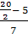 × 5 = 68.6
3- Mode:
Ungrouped:
Mo = 74
Grouped:
Mode = L + { } x C
L- Lower limit of median class
f2- Frequency difference to preceding class of median class.
f1- Frequency difference to succeeding class of median class.
C- Class interval.
Mo= 65 + { } x 5 = 68.0

Q2b/ Compute SD of ungrouped and grouped data of the same variables?

a- Ungrouped SD:

∑X = 1382

N = 20

(∑X)² = 1909924

∑X² = 96182

SD =
SD = 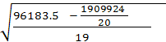 = 6.01
B- grouped SD :
SD =
B.W f mid point fx fx²
55 — 60 1 57 5 57.5 3306.25
60— 65 4 62.5 250 15625
65 — 70 7 67.5 472.5 31893.75
70 — 75 5 72.5 362.5 26281.25
75— 80 3 77.5 232.5 18018.75
n 20 ∑fx 1375 ∑fx² 95125
SD = 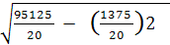 = 5.54

Q3a/ Compute mean , median and mode of following data which represent the body weight of 20 lambs using ungrouped and grouped data.
7, 5.5, 2.5, 8.5, 9, 6, 12, 5, 9, 10.5, 7.5, 13, 3, 10, 9, 4, 14, 11, 16, and 8.
Ans.
1- Mean
a- Ungrouped data:
∑X = 170.5
n = 20
x = 170.5 ÷ 20 = 8.5
b- Grouped data:
Lower limit = 2, upper limit = 17
16 – 2.5 = 13.5, If making 5 group, so the rang =
13.5 ÷ 5 = 2.7 or 3
2 — 5 5 — 8 8 — 11 11 — 14 14 — 17
IIII IIIII IIIII III I
II
4 5 7 3 1

So the frequency table :
B.W f mid point fx cumulative f.
2 — 5 4 3.5 14 4
5— 8 5 6.5 32.5 9
8 — 11 7 9.5 66.5 16
11 — 14 3 12.5 37.5 19
14— 17 1 15.5 15.5 20
n 20 fx 166
Grouped mean x = 166 ÷ 20 = 8.4
2- Median:
a- Ungrouped
first we arrange the data up words
2.5, 3, 4, 5, 5.5, 6, 7, 7.5, 8, 8.5, 9, 9, 9, 10, 10.5, 11, 12, 13, 14, and 16.
The median digit 10 and 11
Me = (8.5 + 9) ÷ 2 = 8.75 Kgm

b- Grouped median:
So the qumulative frequency table :
B.W f cumulative f.
2 — 5 4 4
5— 8 5 9
8 — 11 7 16
11 — 14 3 19
14— 17 1 20
Me = L + × C
L- lower limit of median class
n- Number of observation
F- Cumulative frequency preceding median class
f- frequency of median class
C- Class interval.
= 8 + 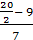 × 3 = 8.4
3- Mode:
Ungrouped:
Mo = 9
Grouped:
Mode = L + { } x C
L- Lower limit of median class
f2- Frequency difference to preceding class of median class.
f1- Frequency difference to succeeding class of median class.
C- Class interval.
Mo= 8 + { } x 3 = 8.99
Q3b/ Compute SD of ungrouped and grouped data of the same variables?
a- Ungrouped SD:
∑X = 170.5
N = 20
(∑X)² = 29070.25
∑X² = 1703.25
SD =
SD = 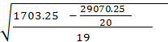 = 3.63

B- grouped
SD =

B.W f mid point fx fx²
2 — 5 4 3.5 14 49
5— 8 5 6.5 32.5 211.25
8 — 11 7 9.5 66.5 631.75
11 —14 3 12.5 37.5 468.75
14—17 1 15.5 15.5 240.25
n 20 ∑fx 166 ∑fx²= 1601
SD = 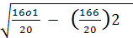 = 3.41
Q4/ What group has a higher variability.
1- Body weight of sheep: 28, 30, 29, 29, 30 Kgm.
2- Length of insects: 1, 2, 6, 7, 7Cm.
Ans.
C.V= x 100
SD =
1- group 1: ∑X = 146
N = 5
X= 29.2
(∑X)² = 4266
∑X² = 21316
SD = 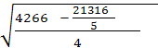 = 0.84
2- group 2: ∑X = 23
N = 5
X= 4.6
(∑X)² = 139
∑X² = 529
SD = 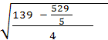 = 2.88
C.V1= x 100 = 2.88%
C.V2= x 100 = 62.60
group 2 more variabl
Q5/ You have three groups of data:
The first one is for Hb% of 10 Awassi sheep, 12, 11, 12, 13, 10, 9, 6, 11, 10, 12%.
The second one is for Hb% of 9 Karradi sheep, 13, 6, 6, 12, 12, 11, 12, 6, 6%.
The third one is for Hb% of 6 Arrabi sheep, 13, 9, 12, 7, 11, 6%.
Which group of data have less viability?
Sol.
C.V= x 100
SD =
First: ∑X = 106
N = 10
X= 10.6
(∑X)² = 1160
∑X² = 11236
SD = 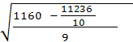 = 2.01
Second: ∑X = 84
N = 9
X= 9.3
(∑X)² = 866
∑X² = 7056
SD = 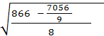 = 3.20
Third : ∑X = 58
N = 6
X= 9.67
(∑X)² = 600
∑X² = 3364
SD = 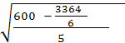 = 2.81
C.V 1st = C.V= x 100 = 18.96%
C.V 2nd = C.V= x 100 = 34.41%
C.V ^{third} = C.V= x 100 = 29.06%
The first group has less variability.

Chapter seven.
Probability – Binomial Distribution
probability
probability: It is the chance factor for an event to occur or not occur.
P_{(E)} = 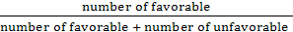
examples:
The probability of student success in 70% or 80%.
The probability of poultry farm production is 90%.
The probability theory had evaluated during 17th century as a result of the separating of card playing.
In 1654 on of the French noble ask one of the arithmetic scientist named Pascal to deal and solute some special problem in card gaming. and after that many scientist appear and constrict many theory concerning card gaming.
There are two values for an event
1- Sure or certainly, where the occurrence is 100% or “1”.
2- Impossible, where the occurrence of the event is “0”.
In life there is no event has a chance or probability to appear 100% or 0, and the probability of the occurrence of an event ranged from 0 to 1.
0 ≤ P ≥ 1
Some of the Probability characters
The occurrence of an event P_{(E)}
The nonoccurrence of an event P_{(Ē)}
1/ P_{(E)} + P_{(Ē)}= 1
2/ 0 ≤ P ≥ 1
3- If E₁, E₂, E₃, ….E_{n} are the elements of the sample space, so the sum of all probabilities :
P = P_{(E1)} + P_{(E2)} + P_{(E3)} +….P_{(En)} = 1
∑ P_{(Ei)} = 1
Example: A box contain 6 balls red, 4 white, and 5 yellow, If one ball sub drawn randomly, what is the probability to be:
1- Red
2- White
3- Yellow
1/ P_{(ER)} =
2/ P_{(EW)} =
3/ P_{(EY)} =
The probability of (red or white or yellow) is:
P_{(ER) +} _{(EW) +} _{(EY)} = + + = 1
Laws of probabilities:
1- Additional law
1- Discordant events, when the events are discordant, the probability of occurrence of (E₁ and E₂) is the sum of their probability.
P_{(E1 or E2)} = P_{E1} + P_{E2}
i.e., P_{(E1 or E2 or E3…En)} = P_{E1} + P_{E2} + P_{E3}…+ P_{En}
Example: 52 vials of different types of poultry vaccine, in a coo box, including 4 vials of Newcastle and 5 vials of Gambaro, If the owner sub drawn one vial randomly, what is the probability to be either Newcastle or Gambaro?
Probability of Newcastle:
P_{(EN)} =
Probability of Gambaro:
P_{(EG)} =
Because P_{(EN)} and P_{(EG)} are Discordant events so the probability of the vaccine vial to be either Newcastle or Gambaro will be:
P_{(EN or EG)} = + =
= 0.36
2- Un discordant events: in this case the probability of each E1 or E2 which represent un discordant events equal to addition of each minus their multiplication.
P_{(E1 or E2)} = P_{(E1) + P(E2) – P(E1.E2)}
Example: Man A shot a target in a ratio and Man B shot the same target in ratio . What is the probability of aiming the target if the two men shot together (A or B or both together)?
P_{(A or B)} = P_{(A)} + P_{(B)} – P_{(A.B)}
P_{(A)} =
P_{(B)} =
P_{(E1 or E2)} = + – ( x )
= = 0.55
2- Multiple laws
1- Independent events : The occurrence of an event not effect on the occurrence of the other event. If E1 and E2 are independent events; the probability of their occurrence is:
P_{(E1 and E2)} = P_{(E1)} x P_{(E2)}
Example 1: Man A shot a target in a ratio and Man B shot the same target in ratio . What is the probability of shot the target at the same time?
P_{(EA and EB)} = x
= = 0.1
Example 2: Box 1 contains 4 ball white, and 2 black. Box 2 contains 3 white and 5 black. If we sub drawn one ball from each, what is the probability to be black (both)?
Black ball from box 1 B1
Black ball from box 2 B2
P(B1 + B2) = P(B1) x P(B2)
= x = 0.21
Example 3: Box contain 20 balls white and 10 red, one ball had been pulled and return to the same box, and again pulled another ball from the box. What is the probability to be red (both balls)?
P_{(R1 + R2)} = P_{(R1)} x P_{(R2)}
= x = = 0.111
2- Un independent events: If E1 and E2 un independent events, the occurrence of the two at the same time equal to multiplying the first event by the second in proportion to the first.
P_{(E1 and E2)} = P_{E1} x P_{(E2/E1)}
Example 1: Five red card and three black one in a file, if we pulled one card and take it out, and pulled another one, what is the probability to both card to be black?
Probability for the first black card = B1
Probability for the second black card = B2
P_{(B1 + B2)} = P_{(B1)} x P_{(B2/B1)}
= x = = 0.167
Example 2: A class with 25 boys and 10 girls, if 3 name had been chosen randomly, what is the probability to be all boys?
First boy : B1, second : B2, third : B3
P_{(B1 + B2 + B3)} = P_{(B1)} x P_{(B2/B1B3)} x _{P(B3/B1B2)}
= x x = 0.351
Probability – Binomial Distribution
Binomial population: Two different categories one with and other without specified attribute.
Binomial distribution: It is probability distribution of all possible outcomes when the sample is from binomial population.
1/ ! = Factorial sign (Factorial of an integer is the product of that number and all successive lower integers.
2/ p and q = There are two mutually exclusive categories are considered for the occurrence of events.
Example: pass, fall
Male, female
Head, tail…. etc.
These two mutually exclusive categories are named as “p” and “q”(where p+q=1 and p= 1-q.
In toss a coin: Tail –T q= = 0.5
Head –H p= = 0.5
p + q= 1
3/ n = size of each sample
4/ x or r = numbers of successes
p= probability of successes
(n-x) or (n-r) = numbers of failures
q= probability of failures
Permutation: Term is selected which are arranged in a specified order.
_{n}P_{x} = 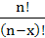
or
_{n}P_{r} = 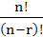
Combination: Term is selected which are not arranged in a specified order.
_{n}C_{x} = = 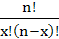
or _{n}C_{r} = = 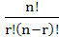
Examples for permutation: 1/ If two letters have been chosen from 4 letters, A, B, C, and D, what are the numbers of procedures that we can choose those letters?
_{n}P_{x} =
n= 4 , x= 2
₄P₂ = 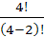 = 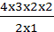 = 12
If four letters have been chosen from 4 letters, A, B, C, and D, what are the numbers of procedures that we can choose those letters?
n= 4 , x= 4
₄P₄ = 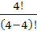 = 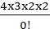 = 48
2/ Digits from 1 to 9 had been written on a carts and puts inside a box , 5 carts had been pulled (one by one), how many five different number figures can be conducted?
_{n}P_{x} = , n=9 , x= 5
₉P₅ = 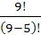 = 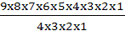 = 15120

Permutation of similar groups
If we use the same rule to find number of time that we can chose the letters of the word door, the result i: ₄P₄ = 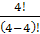 = 24, and this consider as a false result because the letter O written twice, so we use the following law:
P = 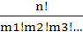
m1: group 1
m2: group 2 …etc.
Example 1: How many ways to arrange the letters of the word door?
P =
n= 4
m1= 2
P = 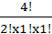 = 12
Example 2: How many ways to arrange the letters of the word successes?
P = 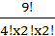 = 3780
Example for combination:
How many ways that we can use to choose a “five person committee from 9 persons?
In this question we see the arrangement of individuals not important,
_{n}C_{x} = =
n= 9
x= 5
₉C₅ = = 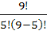 = 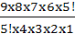 = 126

Probability – Binomial distribution
Its law:
P_{x} = p^{x} q^{n-x}
p= success
q= failure
= number of possible ways that can an event appears in x times from n attempts, this called combination.
Example 1: In one of Mendel’s trails, in crossing pure long plant with pure short plant. In F3 the ratio of long plant to short plant was 3:1 respectively. If we choose 5 plants randomly, what is the probability to get 3 long plants?
P_{x} = p^{x} q^{n-x}
1- Ratio of long plant = p =
2- Ratio of short plant = q =
3- Number of attempts = n = 5
4- Number of long plants= x = 3
P_{x=3} = ﴾ ﴿³ ﴾ ﴿⁵⁻³
= 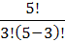 x 0.75³ x 0.25²
= 0.264 the P. to get 3 long plants
Example 2: In one of Mendel’s trails, in crossing pure long plant with pure short plant. In F3 the ratio of long plant to short plant was 3:1 respectively. If we choose 5 plants randomly, what is the probability to get 3 long plants at maximum?
P_{(x≤3)} = P_{x=3} + P_{x=2} + P_{x=1 +} P_{x=0}
P_{x=3} = 0.264
P_{x=2} = ﴾ ﴿² ﴾ ﴿⁵⁻²
= 0.0879
P_{x=1} = ﴾ ﴿¹ ﴾ ﴿⁵⁻¹
= .0146
P_{x=0} = ﴾ ﴿⁰ ﴾ ﴿⁵⁻⁰
= 0.00098
P_{(x≤3)} = P_{x=3} + P_{x=2} + P_{x=1 +} P_{x=0} = 0.367
Example 3: In one of Mendel’s trails, in crossing pure long plant with pure short plant. In F3 the ratio of long plant to short plant was 3:1 respectively. If we choose 5 plants randomly, what is the probability to get 3 long plants at minimum?
P_{x≥3} = P_{x=3} + P_{x=4} + P_{x=5}
Example 4: A basketball player, his chance to get a goal in free shot is , what is the probability to get 2 goals in 4 shoots?
P_{x} = p^{x} q^{n-x}
p =
q =
n = 4
x = 2
P_{x=2} = ﴾ ﴿² ﴾ ﴿⁴⁻²
= 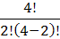 x 0.75² x 0.25²
= 0.211
Example 5: A family have 5 Childs, what is the probability to get 3 male within them?
P_{x} = p^{x} q^{n-x}
p =
q =
n = 5
x = 3
P_{x=3} = ﴾ ﴿³ ﴾ ﴿⁵⁻³
= x 0. 5³ x 0. 5²
= 0.3125
Example 6: A veterinary vaccine factory, the percentage of damaged vaccine vials is 5% . If they choose 10 vials, what is the probability of:
1- All the samples damaged.
2-All the samples applicable.
3- Three vials damaged.
Ans.
1/ P_{x} = p^{x} q^{n-x}
p = 0.05
q = 0.95
n = 10
x = 10
P_{x=10} = ﴾ ﴿¹⁰ ﴾ ﴿¹⁰⁻¹⁰
= 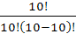 x 0.05¹⁰ x 0.95⁰
= 9.77⁻¹⁴
2/
P_{x} = p^{x} q^{n-x}
p = 0.95
q = 0.05
n = 10
x = 10
P_{x=10} = ﴾ ﴿¹⁰ ﴾ ﴿¹⁰⁻¹⁰
= x 0.95¹⁰ x 0.05⁰
= 0.5987
3/
P_{x} = p^{x} q^{n-x}
p = 0.05
q = 0.95
n = 10
x = 3
P_{x=3} = ﴾ ﴿³ ﴾ ﴿¹⁰⁻³
= 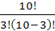 x 0.05³ x 0.95⁷
= 0.0105

Combination and its relation with additional and multiplication laws
They controls by two rules:
1- If the possible way for the event “E1” is “n”, and the possible way for the event “E2” is “m”, and E1 and E2 discordant, so the number of possible ways for the event E1 or E2 is (n+m) ways.
Example: How many ways for choosing heart or spade from the playing cards?
Sol.
Number of playing cards are 52, and the way of choosing heart are 13 times, also the spade 13 times.
P_{(E1 or E2)} = 13 +13= 26 times
2- If the possible way for the event “E1” is “n”, and the possible way for the event “E2” is “m”, and E1 and E2 are independent events, so the number of possible ways for the event E1 or E2 is (nm) ways.
Example 1:
How many ways for choosing heart and spade from the playing cards?
Sol.
P_{(E1 and E2)} = 13 x13=169 times
Example 2:
A flock of sheep, contain 6 Awasi, 4 Arrabi and 2 Karradi. How may ways to select 3 Awasi and 2 Arrabi?
Sol.
4 Awasi = _{nA}C_{xA} = = = 20 ways of selection Awasi
2 Arrabi= _{nR}C_{xR} = = = 6 ways of selection Arrabi
P_{(E1(Awasi) and E2(Arrabi))} = 20 x6=120 ways
Example 3:
A football club consist of 20 individuals,2: guard, 5: defense, 6: middle, 7: attack. How many team can constrict consist of 1:guard, 2: defense, 3: middle and 5: attack.
P_{E} =
1- Guard = P_{E1} = = 2
2- Defense = P_{E2} = = 10
3- Middle = P_{E3} = = 20
4- Attack = P_{E4} = = 21
P_{(x)} = P_{x1} x P_{x2} x P_{x3} x P_{x4}
= 2 x 10 x 20 x 21 = 8400 Ways of selection

